**Lab 6:** JMP instructions

**Goals:**

1. How to compute means for groups of data

**Computing averages for groups of observations:** uses patty.txt.

The hamburger study used last week was repeated. In the second experiment, hamburger pattys were randomly assigned to the treatment (active or control) but the bacterial concentration in each patty was measured three times per patty. So there are 12 experimental units (pattys) and 36 observations. The experimental unit is the patty; the observational unit (in the original data) is plate count. This is a violation of independence. A more appropriate analysis is based on the average count per patty. After averaging, the observational unit is the patty (because one row of data per patty), which is the same as the experimental unit (good).

One appropriate analysis is to calculate the averages for each patty and save them in a new data set. Then, we will analyze that new data set. More advanced courses discuss other approaches.

Read the patty.txt file. You should have a data table with three columns: trt, rep and cfu. There are three cfu values for each rep. We want to average each set of three to get a single mean for each combination of trt and rep.

Select Tables / Summary from the main menu. Define what you want JMP to do in two steps:

1. Put trt and rep into the Group box. This specifies what combination of values identifies each unique group. It doesn’t matter whether a variable is continuous (blue ramp) or nominal (red bars).
2. Select cfu (the variable that will be averaged), left click the black arrow by Statistics to open the Statistics menu, choose mean. At this point, the Summary dialog box should look like:

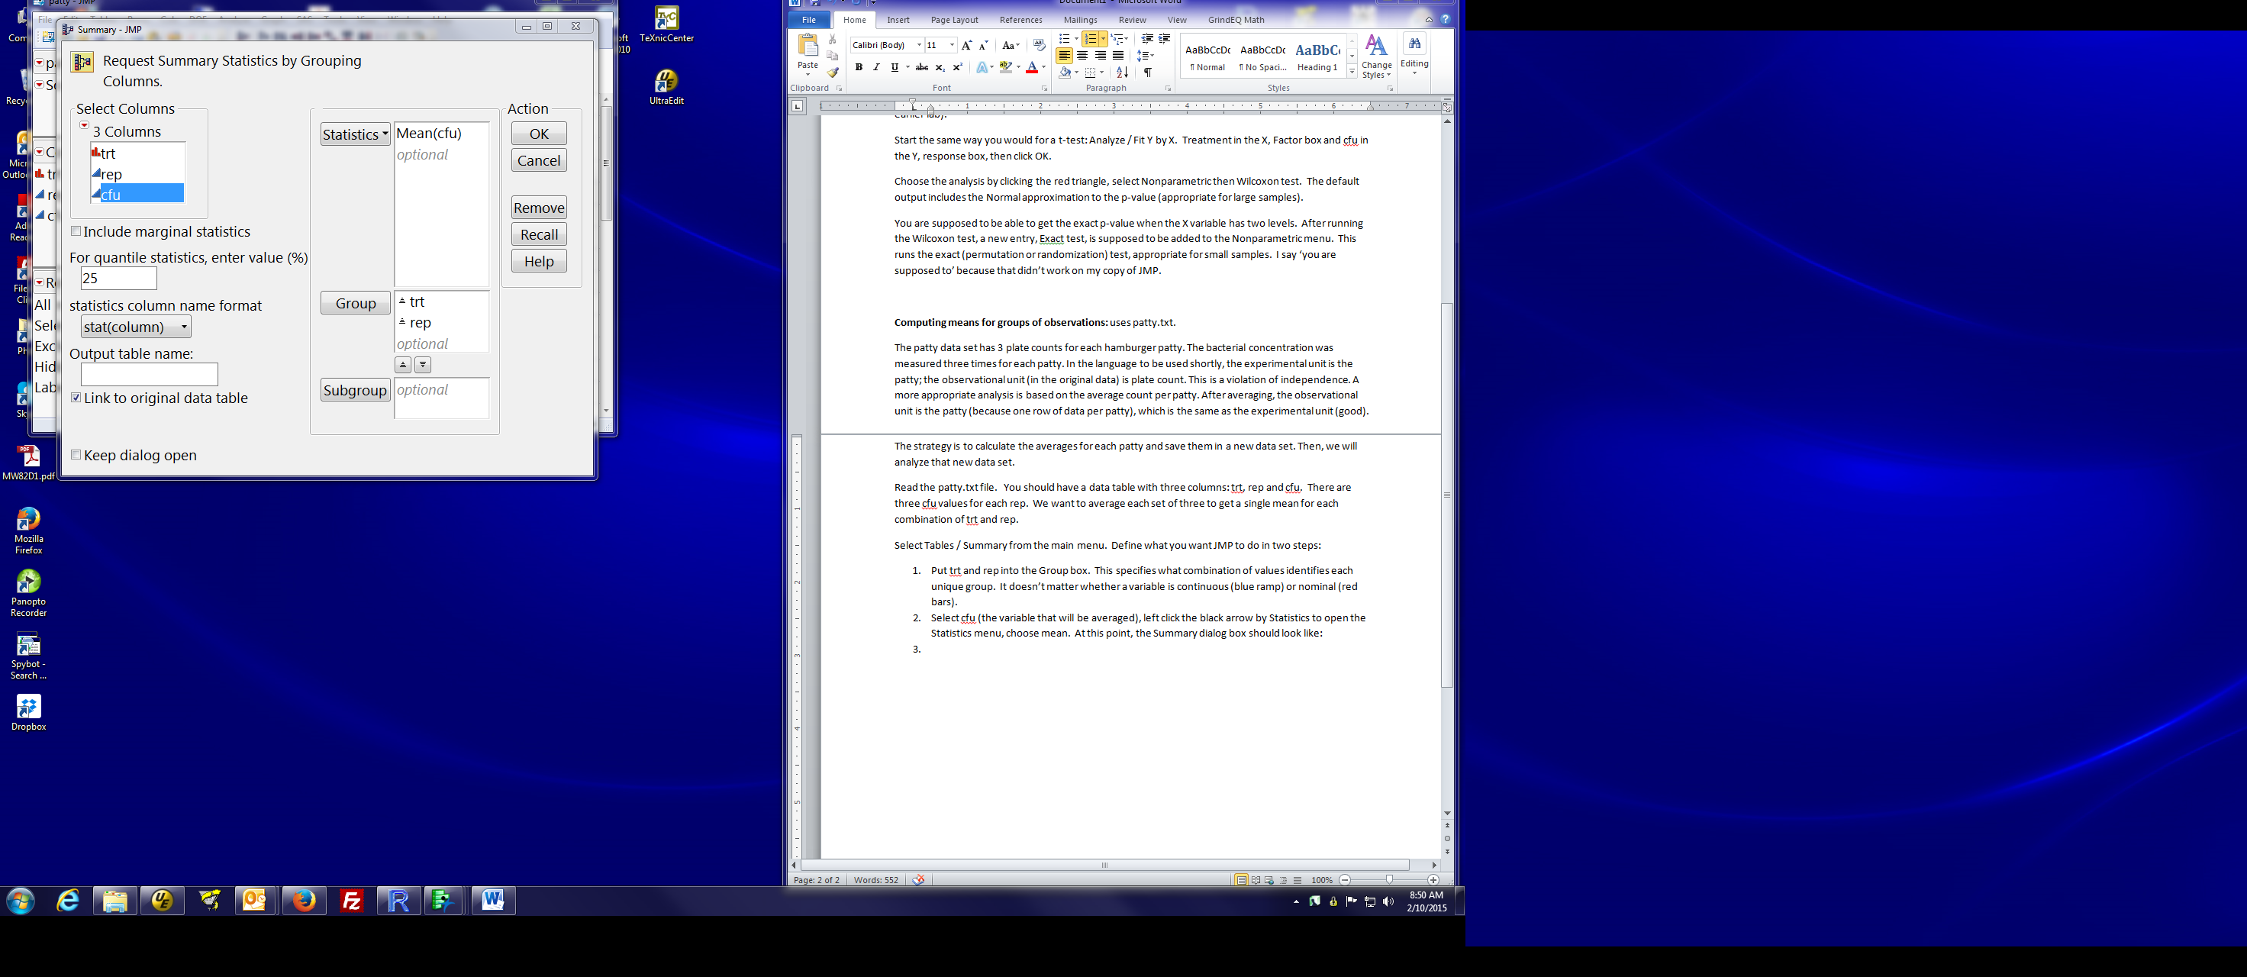

Click OK. You get a new data table with 12 observations, one for each hamburger patty (i.e. combination of treatment and rep). The Nrows column has the number of observations in that group; The mean(cfu) column has the average cfu for each treatment and replicate. You then use this data set for subsequent plots or analyses.

Note: If you forget to include trt as a grouping variable, you get a data set with 6 observations, 1 for each replicate number. The rep 1 value is the average over the 6 values labelled rep 1.

If you forget to include rep as a grouping variable, you get a data set with 2 observations, 1 for each treatment. Both may have their uses, but not for analyzing averages for each combination of treatment and replicate number.

Options:

in the dialog, you give a specific name (Output table name) for the data table in case you don’t like the name JMP generates for you.

After you get the new data table, you can change variable names.